Image Extraction

***GIVEN MATERIAL:***

Extract Green Boxes from given image and paste it in another directory.

***GIVEN IMAGE:***

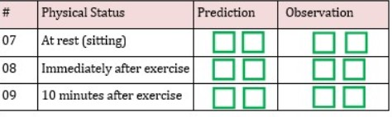

***CODE:***

# Import relevant libraries

import cv2

import os

from matplotlib import pyplot as plt

import numpy as np

from PIL import Image

image = cv2.imread(r'C:\Users\Angshuman Bardhan\Desktop\PI.jpg', -1)

# convert to gray and binarize

gray_img = cv2.cvtColor(image, cv2.COLOR_BGR2GRAY)

binary_img = cv2.adaptiveThreshold(gray_img, 255, cv2.ADAPTIVE_THRESH_MEAN_C, cv2.THRESH_BINARY, 9, 9)

# note: erosion and dilation works on white forground

binary_img = cv2.bitwise_not(binary_img)

# dilate the image

kernel = cv2.getStructuringElement(cv2.MORPH_RECT, (1,1))

dilated_img = cv2.morphologyEx(binary_img, cv2.MORPH_DILATE, kernel,iterations=1)

# find contours, discard contours which do not belong to a rectangle

(cnts, _) = cv2.findContours(dilated_img.copy(), cv2.RETR_LIST, cv2.CHAIN_APPROX_SIMPLE)

sq_cnts = [] # contours of interest to us

print(str(len(cnts)))

for cnt in cnts:

approx = cv2.approxPolyDP(cnt,0.01*cv2.arcLength(cnt,True),True)

#cv2.drawContours(image,[approx],0,(0,255,0),1)

x=approx.ravel()[0]

y=approx.ravel()[1]

if len(approx)==4:

x, y, w, h = cv2.boundingRect(cnt)

aspectratio=float(w)/h

if aspectratio >=1.0 and aspectratio<=1.20:

if x>220 and x!=395:

sq_cnts.append(approx)

print(len(sq_cnts))#No. of Selected Squares which are the green boxes which is 12

f=""

directory = r'C:\Users\Angshuman Bardhan\Desktop\TEST FOLDER'#for new folder location

cv2.drawContours(image,sq_cnts,-1,(0,0,255),1)#outline in red color

cv2.imshow("GREEN BOXES",image)#bordering the green boxes and displaying

for i in range(len(sq_cnts)):

(x, y, w, h) = cv2.boundingRect(sq_cnts[i])

print(x,y,w,h)

newimg=image[y:y+h,x:x+w] # crop the image

newimg=cv2.resize(newimg,(128,128))#resizing the image

f=str(i)+".jpg"

os.chdir(directory)

cv2.imwrite(f, newimg)# writing the image in a different directory

***OUTPUT AND SCREENSHOT:***

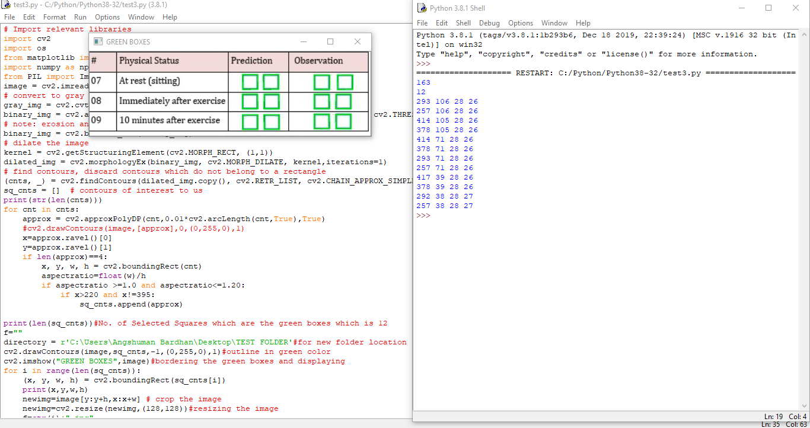

***NEW FOLDER DESTINATION OF GREEN BOXES***

